 **LAB MAUAL -4 LAB TASKS**

**NAME:**

**ASIM ABDULLAH**

**CLASS:**

**ME 15 C**

**CMS ID:**

**463230**

NATIONAL UNIVERSITY OF SCIENCE AND TECHNOLOGY

**LAB TASK -1**

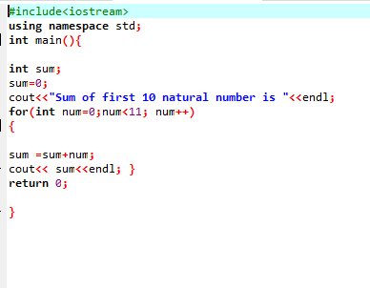

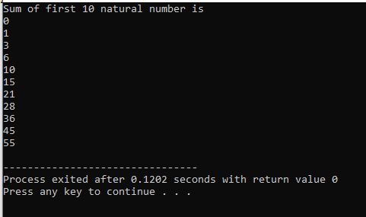

**LAB TASK-2**

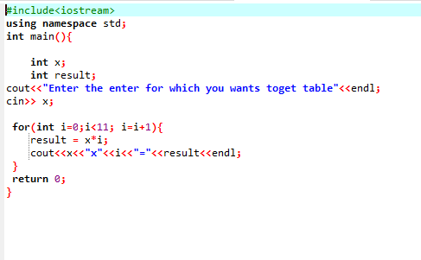

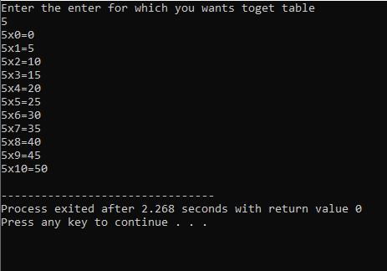

**HOME TASK-3**

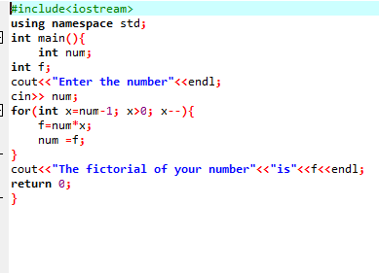

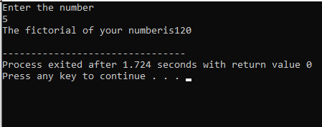

**HOME TASK-4**

